Chemical weathering
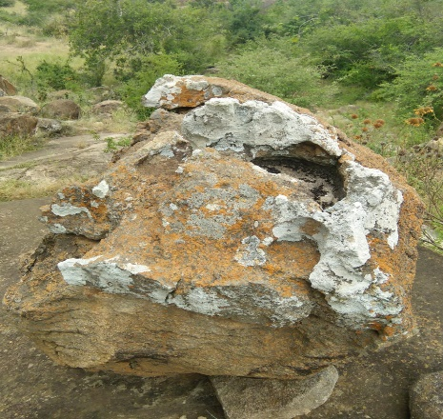Dissolution on a statue: Chemical weathering takes place when the internal part of the mineral consisting or rock changes in addition to other elements. Dissolution, for example, takes place in places where limestone is commonly found. The chemical equation for dissolution is H₂O + CO₂ + CaCO₃ Ca⁺² + 2HCO₃⁻ Dissolution takes place in places where limestone is found. Acidic water dissolves limestone to allow the water to have entrance into the limestone. Dissolutions are evident in sinkholes and gravestone as well as statues such as the example below.
Physical weathering
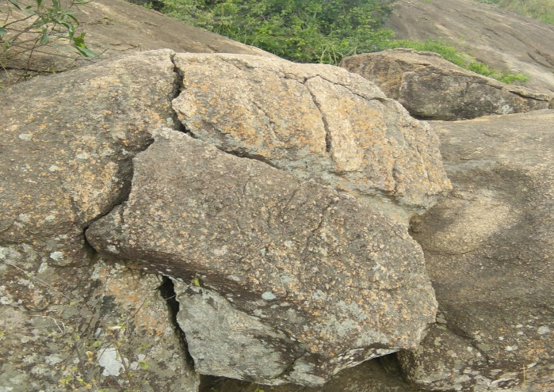 Physical weathering through freeze-thaw action. Freeze and that occurs when rain water seeps into rock cracks over time. During cold season, the water freezes in those cracks. However, when the weather becomes hot, the water expands. The eventual effect on the rock will be breakage of the rock apart; a physical weathering process through freeze-thaw action. The process takes place on mountainous regions through a repeated freezing and expansion of water or even through uneven expansion and contraction of rock surface that is exposed to hot sun especially in deserts.
Biological weathering
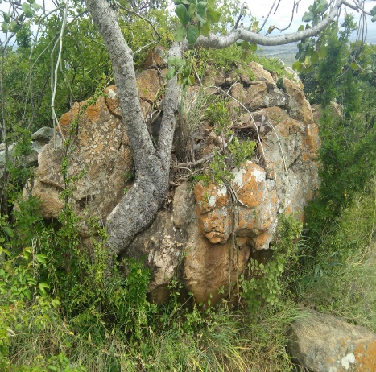Plant creating weathering biologically: Rocks and minerals are disintegrated due to chemical and physical agents of an organism. The roots break apart the rocks by growing into joints and cracks. The plant gives off organic acid that can help in breaking down rocks chemically. Biological activities cause the movement and also minerals to mix. This movement can bring materials to different processes of weathering at different locations in the soil profile.

